Sandhills Horticultural Society’s
And Landscape Gardening Students
Fall Plant Sale

Sandhills Horticultural Gardens.
Saturday, October 14, 2017
8:00 AM till Noon
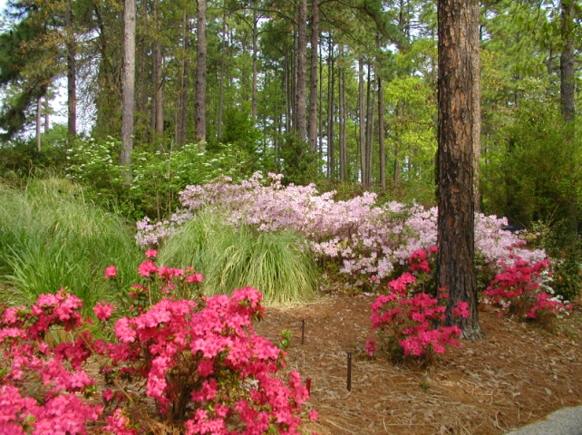

This is an opportunity to support the Sandhills Horticultural Gardens and the Landscape Gardening Students at the college and at the same time obtain excellent locally grown plants. In addition, we are also offering bulbs from Holland.

It is advisable to pre-order these plants. (Final date for pre-orders is October 4, 2017)

Limited numbers of additional plants will be available the day of the sale

You may place your order by calling 910.246.4959

and leaving your name (please spell out), phone number and order OR by completing this form and mailing it with a check payable to SCC-SHS to the following address:

Johanna Westmen
Sandhills Community College

3395 Airport Road
Pinehurst, NC 28374
Pick up your plants on Saturday, October 14, 2017 from
8:00AM until 12:00 Noon
at Steed Hall on the campus of Sandhills Community College.

Quantity Price
3 gallon plants ($18.00 each or 5 for $87.00

Abelia grandiflora ‘Frosty’ – Frosty Abelia
Variegated glossy abelia with white edged small leaves.
Evergreen to semi evergreen shrub. Partial to full sun
White blooms in spring. 2.5’ tall by 2.5’wide _________ _______

Aucuba japonica ‘Variegata’ – Gold Dust Aucuba –
Evergreen, shade, Grows 4-6’ tall _________ _______

Callicarpa americana – American Beautyberry –
Deciduous, grows 3-5’ tall, sun, Iridescent purple
Fruit in the fall _________ _______

Camellia sasanqua ‘ Leslie Ann’ – Leslie Ann
Camellia – White semi-double flowers with each petal edged
in raspberry pink color. Evergreen,
part sun to shade and gets 10-12 feet in height _________ _______

Camellia sasanqua ‘Mine No Yuki’ – Mine No Yuki
Camellia- White.double blooms. Evergreen, part sun
to shade and gets 8-10 feet in height _________ _______

Camellia sasanqua ‘ Sparkling Burgundy’ – Sparkling
Burgundy Camellia – Ruby red double blooms,,
Evergreen, upright spreading growth habit, part sun to shade
and gets 8-10’ tall and 8-10’ wide. ________ _______

Cryptomeria japonica ‘Globosa Nana’ – Globe
Cryptomeria - slow grower reaching 2-3’ tall and
Slightly wider, full sun _________ _______

Euonymus alatus – Burning Bush – Deciduous shrub –
6-8’ – Sun - Brilliant red fall color and red fruit on
winged stems after leaf drop _________ _______

Gardenia jasminoides ‘Kleim’s Hardy’ – Kleim’s Hardy
Gardenia - Single, fragrant white blooms. Evergreen,
partial to full sun that gets 2-3 feet in height. Hardy to
Zone 7 _________ _______

Gardenia jasminoides ‘Radicans’ – Dwarf
Gardenia - Semi-double, fragrant white blooms. Evergreen,
partial to full sun that gets 2-3 feet in height but
spreads 4-5 feet. __________ _______

Ilex x ‘Conaf’ – Oak Leaf Red Holly – Evergreen –
Sun – pyramidal form with small oak leaf like leaves –
14’ tall __________ _______

Quantity Price
3 gallon plants ($18.00 each or 5 for $87.00

Ilex x ‘Conive – Festive Red Holly – Evergreen –
Sun – pyramidal in shape growing to 10’ __________ _______

Ilex crenata ‘Sky Pencil’ – Sky Pencil Holly -
Evergreen – sun – narrow 2-3’ wide and 6-8’ tall __________ _______

Illicium parviflorum ‘Florida Sunshine’ – Florida
Sunshine Anise – semi shade to shade – evergreen –
licorice scented Chartreuse-yellow leaves – 5’ __________ _______

Lagerstroemia indica ‘Ebony Fire’ – Ebony Fire
Crapemyrtle – deciduous, full sun, dark purple leaves
that do not fade all summer long. True red flowers and
upright growth habit. 10-12’ in height _________ _______

Lagerstroemia indica ‘Hopi’ – Hopi
Crapemyrtle – deciduous, full sun, pink blooms –
Semi-dwarf growth habit. 7’ in height ________ _______

Loropetalum chinense ‘Crimson Fire’ – Crimson
Fire Loropetalum, Red Burgundy foliage and pink
flower blooms. Evergreen - Full sun, 2-3’ ________ _______

Loropetalum chinense ‘Dark Fire’ –Dark Fire
Loropetalum - Dark purple leaves and pink flowers.
Full Sun – Evergreen - 5-6’ tall and wide at maturity ________ _______

Loropetalum chinense ‘Ever Red’ – Ever Red
Loropetalum, Dark burgundy foliage with deep red
flowers, Evergreen - full sun, 6-7 feet in height _________ _______

Loropetalum chinense ‘ Garnet Fire’ – Garnet Fire
Loropetalum – Evergreen – Shiny dark burgundy
Foliage- Garnet colored flowers, sun – 5-7’ _________ _______

Miscanthus sinensis ‘Little Zebra’ – Little Zebra
Miscanthus – Sun – Perennial ornamental grass
with tan blooms on stripped yellow and green
Foliage. 3-4’ in height __________ _______

Muhlenbergia capillaris – Pink Muhly Grass
Sun loving, perennial ornamental grass that produces
clouds of pink blooms in the fall. Size ranges from
3-5’ _________ _______

Muhlenbergia capillaris ‘White Cloud’ - Muhly Grass
Sun loving, perennial ornamental grass that produces
Clouds of white blooms in the fall. Size ranges from
3-4’ __________ _______

Quantity Price
3 gallon plants ($18.00 each or 5 for $87.00

Nandina domestica ‘Gulfstream’ – Gulfstream
Nandina – Evergreen – Sun – Brilliant foliage that
becomes darker red in fall. 2-3’ __________ _______

Nasella tenuissima – Mexican Feather Grass – Sun
Perennial ornamental grass that forms airy clumps
12-24” tall – blooming white in the summer __________ _______

Osmanthus fragrans – Fragrant Tea Olive
Sun loving, evergreen, fragrant white blooms in
fall, 10-20 feet in height _________ _______

Panicum virgatum ‘Shenandoah’ – Shenandoah Switch-
Grass – perennial ornamental grass that has reddish pink
Flowers in the summer. Fast grower reaching 4’ _________ _______

Viburnum macrocephalum – Chinese Snowball Viburnum
Semi Evergreen, White flowers in late spring,
Full sun to partial shade, 10-15 tall by 10-15’ wide _________ _______

Viburnum obovatum ‘Mrs. Schiller’s Delight’ – Mrs.
Schiller’s Delight Viburnum – evergreen - sun to partial
shade – white flowers in spring – 2-5’ _________ _______

Viburnum plicatum tomentosum ‘Mariesii’ – Double-
file Viburnum – Sun to partial sun - deciduous –
White flowers in the spring – 6-8’ _________ ______

Roses
Knock Out Double Red _________ ______ Drift Red _________ _______
Drift Pink _________ _______

5 Gallon Specialty Plants ($25.00 each)_____________________________________________

Cornus florida ‘Appalachian Snow’ – Appalachian
Snow Dogwood, Shade, white blooms, mildew
Resistant – 25’ _________ _______

Cornus florida ‘Cherokee Princess’ – Cherokee
Princess Dogwood, Shade, white blooms, mildew
Resistant – 15-30’ _________ _______

Cornus florida ‘Florida Rubra’ – Florida Ruby Dogwood,
Shade, pink blooms, 15-30’ _________ _______

Daffodils ($0.75 each or 50 for $36.00)
Pink Charm (White with pink cup) _______ _______ Dutchmaster (Yellow flower) _______ _______ Mount Hood (White with white cup) _______ _______
Ice Follies (white with light yellow cup) _______ _______
Tete a tete (minature yellow) _______ _______

Allium ($0.85 each or 5 for $4.00
Purple Sensation (4-5” wide purple blooms) _______ _______

Pansies ½ Flat Flat – 36 plants Price
($6.75) ($13.50)
Yellow (no faces) _______ _______ _______
Mixed (with faces) _______ _______ _______
Light Blue (no faces) _______ _______ _______
Dark Blue (no faces) _______ _______ _______
White (no faces) _______ _______ _______

Viola Colors
Yellow (no faces) _______ _______ _______
All Season Mix (no faces) _______ _______ _______

**GRAND TOTAL ** _______________

Name________________________________________________Phone_________

**Sandhills Horticultural Society Members receive a 5% discount for all orders over $100**

