Early Childhood

Student Handbook
2022-2023

Sandhills Community College
3395 Airport Road
Pinehurst, NC 28374
http://www.sandhills.edu/earlychildhood/

Contents

Brief History of the SCC Early Childhood Associate Degree Program
Sandhills Community College Mission Statement
SCC Early Childhood Program Mission Statement
Early Childhood Conceptual Framework (Visual)
Early Childhood Program Description
Early Childhood Associate Degree Program Goals
Key Program Documents
Special Program Requirements
Program Effectiveness
Advising Students
What Makes a Successful Online Learner?

The 7 Habits of Highly Effective College Students
Campus Resources

Early Childhood/Public Services Department Club
Important Contacts

Brief History of the SCC Early Childhood Associate Degree Program
The Sandhills Community College (SCC) Early Childhood program was launched under the leadership of Elizabeth (Betty) High Rounds who directed the program for close to thirty years. Betty died a month before her sixtieth birthday; well before she was ready to retire from the early childhood field.
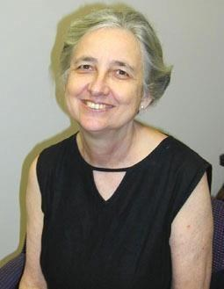
1942-2002

Betty was an energetic, passionate, creative individual who dedicated her life to be an advocate for young children and their families. It is because of her dedication and leadership that Sandhills Community College named the early childhood classroom, the Betty High Rounds Learning Laboratory and dedicated several bronze statues in her honor. The statues appropriately are of children reading. Betty’s great love was children’s literature, and the love of her life, Glen Rounds, was an accomplished author and illustrator of children’s books.

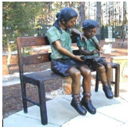
Dedicated June 2003

Ronda Hawkins, longtime friend, colleague and mentee of Betty Rounds, assumed the role of Program Coordinator for the SCC Early Childhood program in 2002. Ronda continued to uphold the mission and values that Betty Rounds had implemented for the program and went on to share her own passions with the program: love of play and outdoor learning. Ronda, who was equally passionate about and dedicated to the field of Early Childhood, worked diligently to share not only with students in the program but with all early childhood educators in the community, state, nation and beyond about the value and benefits of Outdoor Learning Environments (OLE) for children.
Through her collaboration with others in the field she was able to bring to fruition her vision of a Play Mobile that is now owned by the Moore County Partnership for Children and Families and travels around the community allowing many to promote loose parts, outdoor learning and play with children of all ages. Her dream is to someday have an outdoor model classroom/environment in the Sandhills Community College gardens! We are working now to make that happen little by little!

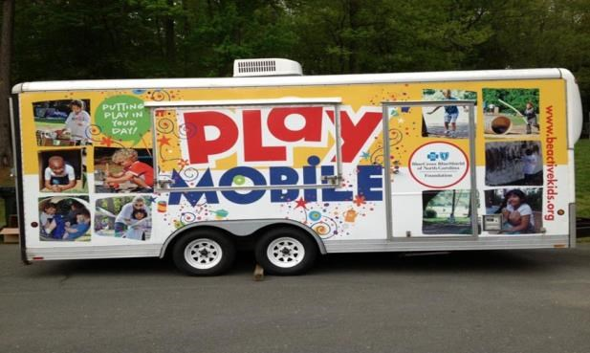
http://www.beactivekids.org/beactive-in-community/play-initiatives/playmobile/

In May 2006, Ronda Hawkins, with the help of Peggy Johnson, SCC Early Childhood Professor and colleague, led the nation in working to have the SCC Early Childhood Associate degree program became one of the first five community colleges in the United States to receive national accreditation from the National Association for the Education of Young Children (NAEYC). In 2013 the program was reaccredited. The stellar reputation of the SCC Early Childhood program today is a direct result of the passion, commitment and vision of Program Coordinator, Ronda Hawkins. Ronda stepped down from her position in 2016 and Susan Wright assumed the role of SCC Early Childhood Program Coordinator. Ronda continues to teach at SCC and is an integral part of the Early Childhood Program… but she now has a bit more time for pursuing her personal and professional passions!

Sandhills Community College Mission Statement
The mission of Sandhills Community College is to provide educational programs of the highest quality to all the people of Sandhills.

What We Believe…
The college is committed to the five core values of INTEGRITY, HELPFULNESS, EXCELLENCE, RESPECT, and OPPORTUNITY. These values guide and direct Sandhills Community College as it seeks:
- To welcome students of all ability levels and to provide programs that prepare them for employment or for transfer (EXCELLENCE);
- To develop student and academic support services that promote student success (HELPFULNESS);
- To provide training for local businesses and to enhance the economic well-being of the region (OPPORTUNITY);
- To contribute to the cultural and artistic richness of the community and to the educational needs of our retired population (INTEGRITY);
- To create a campus environment that celebrates its faculty and staff and supports their personal and professional development (RESPECT).

SCC Early Childhood Program Mission Statement
It is the mission of Sandhills Community College’s Early Childhood program to provide educational opportunities of the highest quality to early childhood students of the Sandhills area of central North Carolina.

One of the most important components of providing high-quality early childhood education and services for young children and their families is planning for the education and preparation of teachers and providers. Research has determined that the most important determinant of the quality of children’s experiences is the adults who are responsible for children’s care and education. At Sandhills Community College, we take our ethical responsibility to provide the highest quality program to our early childhood students very seriously. We provide students with both theoretical knowledge and practical experience while always encouraging reflection, self-evaluation and a commitment to lifelong learning. We are committed to raising the quality of childcare in our community, degree by degree and see ourselves as agents of positive change.

In addition to SCC’s five core values of integrity, helpfulness, excellence, respect and opportunity, our conceptual framework is developed around the values and theories in which Betty High Rounds and Ronda Hawkins so strongly believed. We continue to infuse these values and theories throughout our program today and use them to guide our decision-making process.

- Put children first – always.
- Implement a holistic approach to teaching and learning.
- Remove barriers to learning.
- Inspire a love of reading.
- Encourage self-reflection.
- Collaborate with others and trust in the abilities of the group.
- Promote creativity.
- Grow role models, mentors, leaders and advocates.
- Be goal driven and celebrate success.
- Embrace life-long learning.
- Be engaged and have fun.
- Foster respectful relationships.
Our program is grounded in NAEYC’s standards, developmentally appropriate practice (DAP) and a playful and practical approach to teaching and learning. Students learn multiple theories of child development and how these theories are reflected in developmentally appropriate practice. We have a strong emphasis on the value and benefits of nature and outdoor learning as well as the power of play.

We teach our students utilizing the North Carolina Foundations for Early Learning and Development (NCFELD) guide, the North Carolina Division of Child Development and Early Education (DCDEE) rules and regulations, current NC initiatives and a variety of research-based organizations focused on early care and education. Our students engage and learn through practical hands- on experiences, fieldtrips, observations at local childcare centers and community guest speakers. They learn to implement curricula based on young children’s interests and developmental needs.

Students begin to learn about NAEYC’s associate degree standards in EDU 119: Introduction to Early Childhood Education as they begin work on their early childhood professional portfolio which is centered on the NAEYC standards. They synthesize their understanding in EDU 284: Capstone Practicum when they complete their professional portfolio and engage in a mock interview.
https://www.naeyc.org/resources/position-statements/professional-standards-competencies

Upon graduation, SCC early childhood associate degree students will be proficient in the NAEYC standards, NCFELD, DAP, Play-Based learning and OLE. SCC students will have developed an understanding about the importance of respectful relationships with young children. They will have a “toolkit” to take with them to help teach necessary social/emotional skills to all children and families. SCC students will have a strong understanding of the benefits of early literacy and the power of reading aloud to young children. And lastly, our students will know how to advocate, at all levels, in a respectful and professional manner in order to stand up for what is right in the field of Early Childhood Education.

Early Childhood Conceptual Framework (Visual)

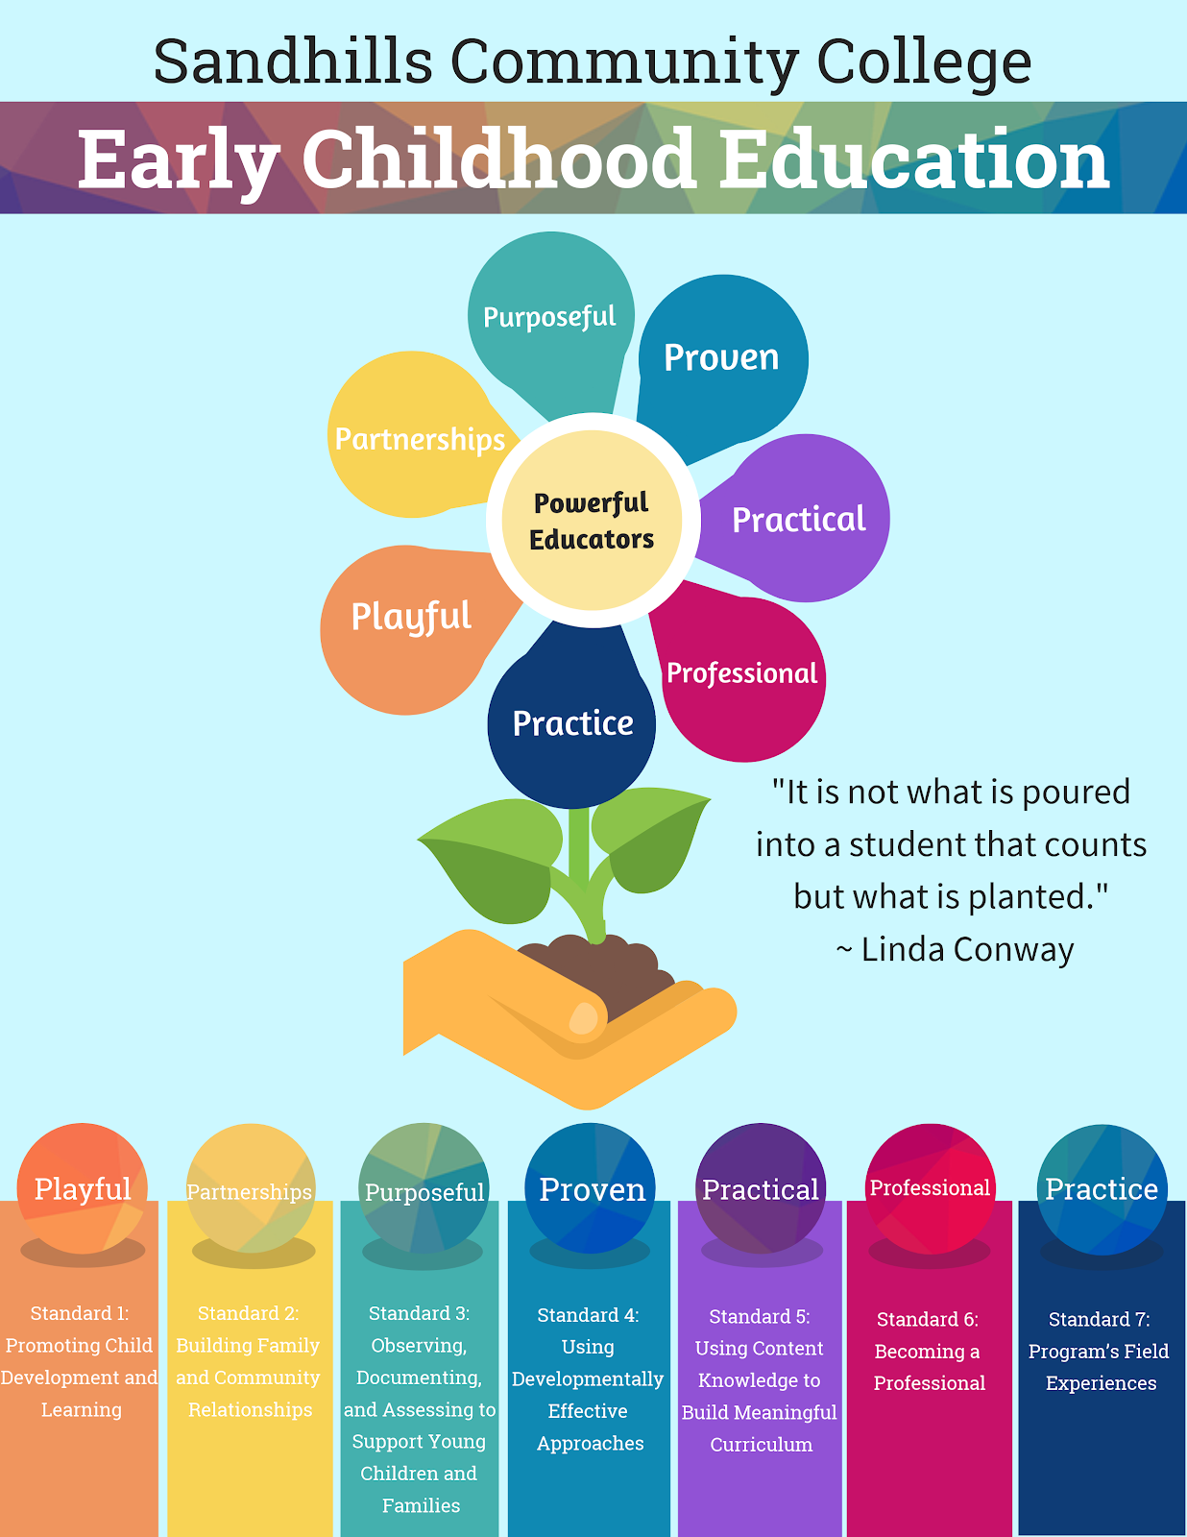

Early Childhood Program Description

The Early Childhood Education curriculum prepares individuals to work with children from birth through age eight in diverse learning environments. Students learn to foster the development of young children in each of the following domains: Approaches to Play and Learning, Emotional/Social, Health/Physical, Language/Communication and Cognitive. Graduates are prepared to plan and implement developmentally appropriate programs in early childhood settings. Employment opportunities include child/family organizations, childcare programs, preschools, public and private schools, recreational centers, Head Start Programs, and school-age programs.

The SCC Early Childhood program offers the following three Associate Degree pathways: Early Childhood Associate Degree (A55200), Early Childhood Associate Birth- Kindergarten
Licensure Transfer Degree (A55220L), and Early Education Non- Teaching Licensure Transfer Degree (A55220NL). In addition, the program offers the following three certificates: Infant/Toddler Certificate (C55220IT, Preschool Certificate (C55220P) and Administration Certificate (C55220A). We offer early childhood classes online, at our main Pinehurst campus and at the Hoke Sandhills Community College Center. We also offer a High School certificate. (*Since COVID, all of our classes are now offered online.) Students who wish to transfer to a 4-year school and pursue a bachelor’s degree in Birth to Kindergarten in order to teach Kindergarten and below should pursue our A55220L degree. Students who wish to transfer to a 4-year school and pursue a bachelor’s degree in Early Care and Education in order to work for organizations that support children and families, but NOT teach, should pursue our A55220NL degree. Students who wish to work in childcare but do not plan to transfer to a 4-year school should pursue our A55220E degree. All students should think about adding on a certificate which they can earn along the way to their Associate Degree and the certificate will show that they are highly qualified in one area of childcare. We encourage our students to pursue employment in the field of Early Childhood while they are completing their classes at SCC.

In North Carolina, lead teachers in a childcare center must meet only two requirements: they must be 18 years of age and have completed one college level 4 credit course: EDU 119 – Introduction to Early Childhood Education with a grade of a C or higher. Everyone working with children, whether as an assistant or a lead teacher, must pass a Criminal Background Check. NC law prohibits anyone convicted of a felony from working with children.

We feel that it is important to offer certificates to encourage our students, as well as
existing childcare providers without formal education, to pursue professional development in a nonthreatening, non-overwhelming way. Our hope is that once they begin their educational process, they will view their certificate as a steppingstone to one of the Early Childhood Associate degrees. The certificate programs support providers in their efforts to provide quality childcare.
Please find our current Course Requirements on the Sandhills Community College’s Early Childhood web page: http://www.sandhills.edu/earlychildhood/

Early Childhood Associate Degree Program Goals
Program Mission and Competencies are achieved by the accomplishment of our goals to:

- Educate and prepare students for careers in the field of early childhood and to assist them in securing employment in those fields;

- Prepare students to transfer to baccalaureate institutions specializing in early childhood;

- Provide challenging learning opportunities, including work and service-learning experiences, that prepare students to work with young children and their families in diverse settings;

- Value and use student feedback to improve courses and meet students needs.

- Monitor program and service performance in each of the above areas and to use the data gathered to improve the program's effectiveness.

Key Program Documents
NC Foundations for Early Learning and Development:
http://ncchildcare.nc.gov/pdf_forms/NC_foundations.pdf

NAEYC Code of Ethical Conduct and Statement of
Commitment: Revised April 2005, Reaffirmed and Updated May 2011 http://www.naeyc.org/files/naeyc/image/public_policy/Ethics%20Position%20Statement201 1_09202013 update.pdf

NAEYC Code of Ethical Conduct Supplement for Early Childhood Program
Administrators Adopted July 2006, Reaffirmed and Updated May 2011
http://www.naeyc.org/files/naeyc/image/public_policy/Supplement%20PS2011_09202013u
pdate.pdf

NAEYC Code of Ethical Conduct Supplement for Early Childhood Adult Educators Adopted Spring 2004
http://www.naeyc.org/files/naeyc/image/public_policy/Supplement%20PS2011_09202013u
pdate.pdf

Special Program Requirements
- NC law prohibits anyone convicted of a felony from working with children.

- Associate Degree Students are required to work a minimum of 144 hours in EDU 284 over the course of a semester in an assigned quality early childhood environment working directly with young children. The student is responsible for transportation to off-campus Practicum sites and for complying with all off-site regulations.

- NC Division of Child Development and Early Education requires that everyone working directly with children have a TB test done prior to their first day working with children. Practicum sites may also require a criminal background check and drug testing to be done prior to the first day of work/class.
https://ncchildcarecbc.nc.gov/

Program Effectiveness
Program effectiveness of the Early Childhood Education curriculum at Sandhills Community College is measured and monitored by the Department of Public Services, the Early Childhood Program Coordinator, and the Office of Planning and Research. The Early Childhood (EC) program establishes and measures its own outcomes in accordance with its purpose and mission as well as the mission of the college. Outcomes are measured and updated annually by the Program Coordinator in conjunction with the Office of Planning and Research.

Current students, graduates, practicum supervisors, employers, and non-completers of the program are evaluated annually. At the end of each course, students evaluate the instructor. This is done anonymously and is sent to the Dean of Instruction who reviews the results prior to sharing this information with the Department Chair and Instructors. Feedback is taken seriously and used to improve our teaching and better meet the needs of our students.
*Students are encouraged to fill out surveys and instructor evaluations every time they are offered. Student feedback is critical to program improvement.

Advising Students
Each student is assigned an advisor. Students meet with advisors, virtually or face to face, prior to registering for classes each semester and at any other point in time when they feel the need to discuss their career goals, progress, or any other pertinent issue. It is the student’s responsibility to schedule time with their advisor. Students are also able to register themselves using Self-Serve found in the SCC Student Portal. *We highly encourage students to meet with their advisor each semester prior to registering for classes. When students are ready to graduate, it is the responsibility of the student to apply online by the SCC deadline.

What Makes a Successful Online Learner?
Source: Minnesota Online High School and Minnesota Department of Education
Two key advantages of online learning are flexibility and convenience. But online learning is a lot more challenging than it may seem. Are you considering taking some or all of your courses online? Good for you! But first, make sure you're ready to succeed. Online learning can sound so wonderful that some students start with an unrealistic vision. In reality, online courses require just as much, if not more, time and energy as traditional classroom courses. It also requires specific computer skills and learning strategies in order to succeed. To see if you're ready, see how many items of the following skills you have:

1. Persistence
Persistence is perhaps the biggest key to success in online learning. Students who succeed are those who are willing to tolerate technical problems, seek help when needed, work daily on every class, and persist through challenges.

- When you run into a challenge, keep trying and ask for help.

- Set up a manageable study schedule for yourself and stick to it. Students who succeed are those who log in and make progress every day. This is especially important after the novelty of going to school online starts to wear off!

2. Effective Time-Management Skills
You must be able to manage your time well. Most courses are not taught in real time. There are no set times for classes. This flexibility is one of the great benefits of online learning. It can also be a drawback for a student who procrastinates, is unable to stick to a routine study schedule, or is not able to complete assignments without daily reminders from a teacher.
Effective time-management skills don't just happen. They have to be learned. Once you do, they will benefit you throughout your life. Follow the tips below to develop yours:

- Review the syllabus for each of your courses. Develop a long-term plan for completing your major assignments.

- Make a daily "To Do" list. Have fun checking things off the list as you complete them.

It takes time to develop good habits, but you'll gain satisfaction from being well-organized and accomplishing your tasks.

3. Effective and Appropriate Communication Skills
Communication skills are vital in online learning because students must seek help when they need it. Teachers are willing to help students, but they are unable to pick up on nonverbal cues, such as a look of confusion on a student's face. Follow these tips:

Use the tools provided by the school to communicate with your teachers. Many online schools and programs provide several ways for students and/or parents to communicate with teachers and staff. These might include e-mail, discussion groups, chat room office hours, cell phones, and even text messaging. Teachers and staff want to help you to succeed in your classes and will answer your questions. It may feel awkward to talk with your teachers this way, but don't worry. If your teacher has chat room or cell phone office hours, don't be shy about using those tools to communicate with your teacher.

Use appropriate style and language for school. When communicating with teachers and other staff, you should write in full, grammatically correct sentences and with a respectful tone. Many students are used to a very informal style of writing in chat rooms, blogs, text messages, and so forth.

Because of the distance, it's tempting for some students to say things out of anger or frustration that they would never say to a teacher in person. Online teachers are professionals. Treat them with respect and courtesy.

4. Basic Technical Skills
Online learners need basic technical skills to succeed. These include the ability to create new documents, use a word processing program, navigate the Internet, and download software.

Most online schools have new student orientation programs. These teach students how to use the school's learning management system and other online tools, but they typically don't cover the basics. If you lack basic computer skills, you may want to find an online tutorial such as the one available through The Library Network. You'll also want to check the online school's main website for their hardware and software requirements. Make sure your own computer meets those requirements.

5. Reading and Writing Skills
Reading and writing are the main ways you'll communicate in an online class. Although some hard copies of textbooks might be required, you should be comfortable reading a lot of documents on a computer screen and able to type.

Some tests and quizzes have multiple choice questions, but many of your assignments will involve writing short or long answers. If you type less than 25-30 words per minute, it may be worth completing a typing software program before beginning online classes.

6. Motivation and Independence
To be successful, an online student has to want to succeed. Online learning requires independence, internal motivation, responsibility, and a certain level of maturity.
Have you given some thought to your own personal reasons for attending school?
Are you determined and self-motivated to succeed in school?
There are many worthwhile reasons to work hard in school. You might want a greater level of personal satisfaction with your future career. Or perhaps it's personal pride in your accomplishments. Or maybe you are seeking a wider range of opportunities available to you with higher education or a higher income.

7. A Good Study Environment
Another critical component of academic success is a good study environment.
- Get some peace and quiet. You will need a quiet place to work without distractions from things like television, family, or roommates.
- Avoid games. Consider uninstalling any computer games to avoid temptation. Or keep the games on a different computer in the house.
- Turn off your cell phone. Let friends and family members know the hours that you will be "at" school.
- Beware surfing the black hole of the Internet. It is easy to lose track of the time as you wander from site to site.
- Consider ergonomics. Adjust the height of your chair, keyboard, and screen so that you are comfortable. Forearms and thighs should be level and parallel to the floor. Wrists should not be bent while typing.
- Set up good lighting and comfortable seating. Lighting in the room should be at least as bright as the computer screen to avoid eye strain.

The 7 Habits of Highly Effective College Students
https://www.franklincovey.com/Solutions/education/higher_education/7habitscollege.html

Self-management
Habit 1: Be Proactive® I am responsible for my education and life.

Habit 2: Begin with the End in Mind® I have a plan for what I want to accomplish.

Habit 3: Put First Things First® I do the most important things first.

Interpersonal skills and teamwork
Habit 4: Think Win-Win® I am considerate of others, but I also have the courage to stand up for myself.

Habit 5: Seek First to Understand, Then to Be Understood® I hear people out before expressing my own opinion.

Habit 6: Synergize® I value the strengths of other people and combine them with my own to solve problems.

Wellness
Habit 7: Sharpen the Saw® I regularly recharge my body, heart, mind, and spirit so I can stay sharp and improve myself.

Campus Resources

Learning Resource Center
The Learning Resource Center is an open computer lab located within Boyd Library. The LRC is equipped with networked computers and printers. A variety of software is installed on each computer. All provide Internet access. The Learning Resource Center is fully staffed. Staff members are trained and ready to answer any questions you may have.

Tutoring Center
The Tutoring Center provides one-on-one tutorial sessions or small group instruction for all students needing extra assistance in enrolled classes or in their preparation to enter a chosen curriculum. The intention of the Tutoring Center is to assist and encourage students in their educational advancement. Tutoring is offered free of charge. The college now has a Writing Lab, Math Lab and Speaking Lab for students to use as well, free of charge.

Boyd Library
The Boyd Library has provided excellent support to the Early Childhood Program. They are responsive to our requests for adding additional resources to the library collection. Representatives from the library have come to our classes to teach our students how to do effective online searches using the databases as well as point them to the online tutorials and resources for class. They also provide tours of the library pointing out locations of important early childhood materials.

SCC Counseling Center and SCC Career Center
Students can receive free and confidential personal counseling from our professional counselors on campus. Students can also seek career counseling at our Career Center.

Important Contacts

Susan Wright
Program Coordinator, Professor, Early Childhood Education
Email: wrightsu@sandhills.edu
Office: Van Dusen 217
Phone: (910)246-5360

Ronda Hawkins
Professor, Early Childhood Education
Email: hawkinsr@sandhills.edu
Office: Van Dusen 229
Phone: (910)695-3808

Aimie Hoover
Adjunct Professor, Early Childhood Education
Email: hoovera@sandhills.edu

Taylor McCaskill
Adjunct Instructor, Early Childhood Education
Email: mccaskillt@sandhills.edu

Mehera Ardinger
Adjunct Instructor, Early Childhood Education
Email: ardingerm@sandhills.edu

Nichole Holloway
Faculty Secretary, Early Childhood
Email: hollowayn@sandhills.edu
Office: 222 Van Dusen Hall
Phone: (910)695-3963

